**UNIDAD EDUCATIVA**

**“ISABEL DE GODÍN”**

**HOMEWORK**

**Name:** Viñán Ana **Course:** 3º “B” Contabilidad **Date:** 2015-05-06

**Sentences with *must.***



1. Harry must eat vegetables - Harry must not eat vegetables

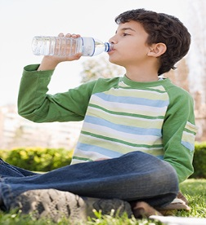

1. Jake must drink four water bottles – Jake must not drink four water bottles

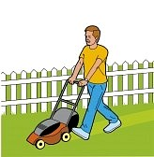

1. Peter must cut the grass – Peter must not cut the grass

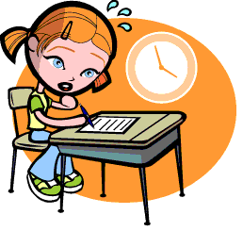

1. Emily must does her homeworks – Emily must not does her homeworks



1. Jane must wash the car – Jane must not wash the car



1. Cristopher must clean the house – Cristopher must not clean the house



1. Mary must go to work – Mary must not go to work

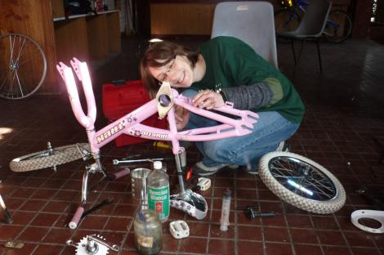

1. Grace must fix the bicycle – Grace must not fix the bicycle

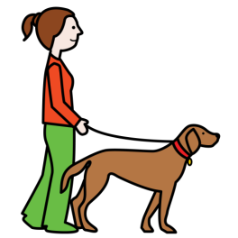

1. Jessica must walk the dog – Jessica must not walk the dog

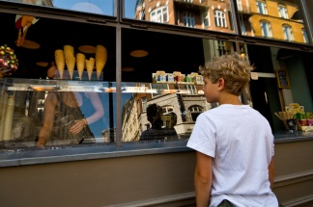

1. Daniel must buy a cake – Daniel must not buy a cake